Structure of this paper

Section | Number of questions available | Number of questions to be answered | Working  time (minutes) | Marks available | Percentage of exam
Section One:  Calculator-free | 7 | 7 | 50 | 50 | 35
Section Two:  Calculator-assumed | 12 | 12 | 100 | 100 | 65
 |  |  | Total | 150 | 100

Instructions to candidates

- The rules for the conduct of examinations are detailed in the school handbook. Sitting this examination implies that you agree to abide by these rules.

- Write your answers in this Question/Answer Booklet.

- You must be careful to confine your response to the specific question asked and to follow any instructions that are specified to a particular question.

- Spare pages are included at the end of this booklet. They can be used for planning your responses and/or as additional space if required to continue an answer.
- Planning: If you use the spare pages for planning, indicate this clearly at the top of the page.
- Continuing an answer: If you need to use the space to continue an answer, indicate in the original answer space where the answer is continued, i.e. give the page number. Fill in the number of the question that you are continuing to answer at the top of the page.

- Show all your working clearly. Your working should be in sufficient detail to allow your answers to be checked readily and for marks to be awarded for reasoning. Incorrect answers given without supporting reasoning cannot be allocated any marks. For any question or part question worth more than two marks, valid working or justification is required to receive full marks. If you repeat any question, ensure that you cancel the answer you do not wish to have marked.

- It is recommended that you do not use pencil, except in diagrams.

- The Formula Sheet is not to be handed in with your Question/Answer Booklet.

Section Two: Calculator-assumed 65% (100 Marks)
This section has twelve (12) questions. Answer all questions. Write your answers in the spaces provided.

Working time for this section is 100 minutes.

Question 8 (7 marks)
The number of votes still to count at the end of an election decreased by 72 every minute after 6 pm. At 6 pm, 2955 votes still needed counting.

(a) Show that by 6:02 pm, 2811 votes still needed counting. (1 mark)
Solution
votes
Specific behaviours
shows calculation

(b) Deduce a non-recursive rule for , the number of votes still needing counting n minutes after 6 pm. (2 marks)
Solution
or T_{n}= 2883 – 72(n – 1)
Specific behaviours
uses initial number and difference
states correct rule

(c) Determine how many votes still needed counting at 6:30 pm. (1 mark)
Solution
votes Follow Through - 867
Specific behaviours
determines number of votes

(d) At 6:30 pm, counting slowed so that only 36 votes were processed every minute. Determine the time, to the nearest minute, that counting finished. (3 marks)
Solution
Specific behaviours
states new rule  solves for n  determines correct time of day | - 1 mark if n-1

Question 9 (8 marks)
(a) Describe a suitable method to organise and display data when investigating the existence of an association between two categorical variables. (2 marks)
Solution
A two-way frequency table, with either row or column percentages. Might also choose to construct a stacked bar graph.
Specific behaviours
states frequency table
indicates need to calculate row or column percentages

(b) A class was set a task to investigate whether an association exists between the distance a student lived from school and the number of times they were late in a term.

(i) What type of graph would be appropriate to display data collected? (1 mark)
Solution
A scatterplot
Specific behaviours
states graph type

(ii) What statistical measure would be useful to calculate in order to determine whether an association existed? (1 mark)
Solution
Correlation coefficient or coefficient of determination
Specific behaviours
states measure

(iii) One student designed the questionnaire shown below. Comment on the appropriateness of their design for this investigation. (2 marks)

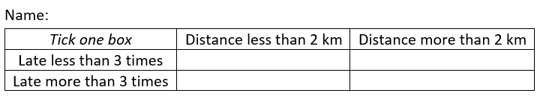
Solution
Not very appropriate or useful
- Better to record exact distances and number of lates for each person
- Late group boundary doesn't allow for 3 lates, etc
Specific behaviours
comments that form not good
supplies reasons

(iv) A student carried out the investigation, found that a moderate negative association existed, and concluded that frequent lateness was caused by living close to the school. Comment on their conclusion. (2 marks)
Solution
Conclusion implies that one causes the other, which may not be true. All that can be concluded is that an association exists between the variables.
Specific behaviours
disagrees with conclusion
notes causation implied

Question 10 (8 marks)
A media company sought responses from the general public to the question "How much trust do you have in the following for information about asylum seekers?". The company were investigating whether the source of information was associated with the degree of trust the general public placed in the information about asylum seekers.

The responses are summarised in the table below.

 | Degree of trust in asylum seeker information
Information source | Some trust | Little trust | Not sure
Politicians | 27 | 117 | 16
The media | 25 | 84 | 11
Doctors | 99 | 61 | 20
Churches | 54 | 80 | 16

(a) Name the explanatory and response variables for this investigation. (2 marks)
Solution
Explanatory is SOURCE and response is DEGREE OF TRUST
Specific behaviours
states correct explanatory variable
states correct response variable

(b) Complete the table of percentages below, rounding to the nearest whole number, so that it can be used to identify whether the source of information is associated with the degree of trust the general public place in the information. (4 marks)

 | Degree of trust in information
Information source | Some trust | Little trust | Not sure
Politicians | 17 | 73 | 10
The media | 21 | 70 | 9
Doctors | 55 | 34 | 11
Churches | 36 | 53 | 11
Solution
See table - using row totals of 160, 120, 180 and 150.
Specific behaviours
calculates row totals calculates one row of percentages
rounds to whole numbers completes all row percentages

(c) Comment on whether this data provides any evidence that the source of information is associated with the degree of trust placed in the information about asylum seekers.
(2 marks)
Solution
Yes - an association exists. Only 17% have some trust when the information source is a politician compared to 55% when the source is a doctor.
Specific behaviours
States that evidence exists
uses an example to support claim

Question 11 (9 marks)
Sequence T is defined given by .

(a) Use the recursive rule to complete the table below, rounding values to one decimal place. (2 marks)

n | 1 | 2 | 3 | 4 | 5 | 6
 | 50 | 62.5 | 78.1 | 97.7 | 122.1 | 152.6
Solution
See table
Specific behaviours
calculates at least three correct values
calculates all correct values

(b) Graph the first six terms of sequence T on the axes below. (2 marks)

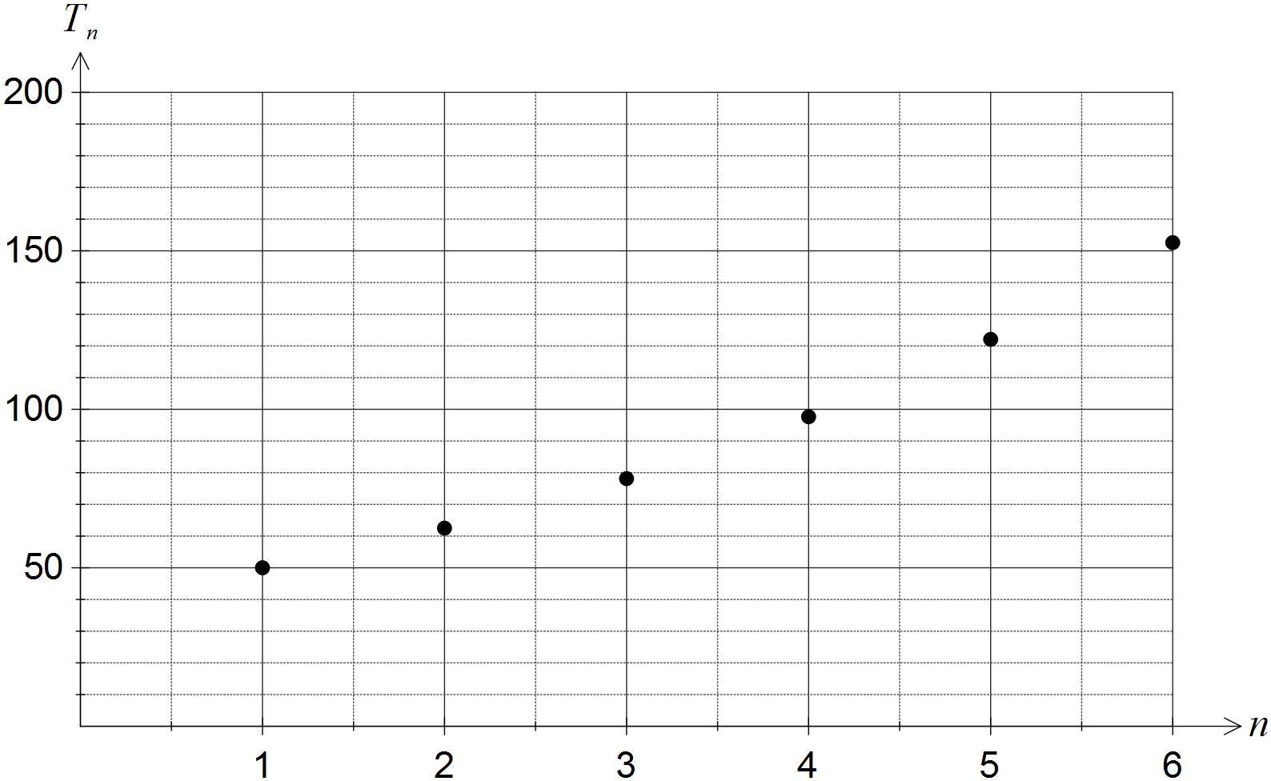
Solution
See graph - does not join points
Specific behaviours
plots three points accurately
plots all points accurately and does not attempt to join them

The first three terms of the geometric sequence U are 200, 160 and 128.

(c) Deduce a rule for the n^{th} term of sequence U. (2 marks)
Solution
Specific behaviours
calculates ratio of terms
writes general rule for n^{th} term

(d) Determine . (1 mark)
Solution
Specific behaviours
calculates term

(e) Determine the largest value of n so that , justifying your answer. (2 marks)

Solution
Specific behaviours
states correct value of n
justifies answer

Question 12 (8 marks)
The daily customer satisfaction index was measured by an online business over a period of ten consecutive days and the data collected is shown in the table below.

Day (d) | 1 | 2 | 3 | 4 | 5 | 6 | 7 | 8 | 9 | 10
CS Index (s) | 92.1 | 91.2 | 90.6 | 88.9 | 88.1 | 87.7 | 87.4 | 86.6 | 85.4 | 85.1

(a) Plot the above data on the axes below. (2 marks)

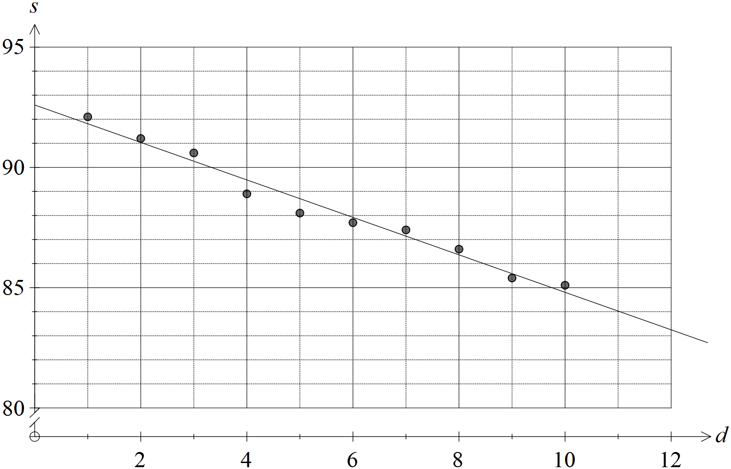
Solution (c)
See graph
Specific behaviours
correct intercept at 92.5
correct gradient - lines passes through (11, 84)

Solution (a)
See graph
Specific behaviours
plots at least six points accurately
plots all points accurately

(b) Determine the equation of the least-squares line that models the linear relationship between the day number and the customer satisfaction index. (2 marks)
Solution
Specific behaviours
determines gradient and intercept
uses correct variables

(c) Draw the least-squares line on the axes above. (2 marks)

(d) Predict the customer satisfaction index for day 11. (1 mark)
Solution
Specific behaviours
calculates value

(e) Explain why a prediction for the customer satisfaction index for day 15 should be treated with caution. (1 mark)
Solution
Prediction involves considerable extrapolation.
Specific behaviours
comments on extrapolation

Question 13 (9 marks)
A business has branches in six cities. The table below shows the time, in minutes, it takes for a package received at one branch to be transported to a branch in another city, where a direct route exists.
Q | 40
R | - | 50
S | - | 25 | 30
T | 30 | 35 | - | 25
U | 25 | - | - | 65 | 35
 | P | Q | R | S | T

(a) Construct a weighted graph to show this information, using the cities placed below.
(3 marks)

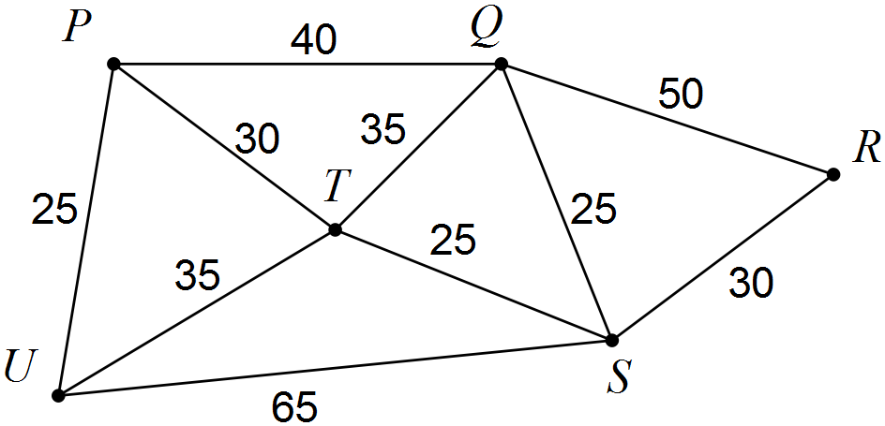
Solution
See diagram
Specific behaviours
correctly adds at least 7 edges
adds all edges correctly
labels all edges correctly

(b) Determine the shortest transport time for a package to travel from

(i) P to S. (1 mark)
Solution
55 minutes
Specific behaviours
states correct time

(ii) Q to U. (1 mark)
Solution
65 minutes
Specific behaviours
states correct time

(c) A document needs to be sent from branch U via branch R, where a customer will sign the document, to branch P. Determine the minimum transport time for the document to make this journey, listing all branches on the way. (2 marks)
Solution
U - T - S - R - S - T - P = 175 minutes
Specific behaviours
states minimum time
lists branches

(d) Another business document requires signing by the manager of each branch. In planning a route for this document, would finding a Eulerian trail be more appropriate than finding a Hamiltonian trail? Explain your answer. (2 marks)
Solution
No. Hamiltonian is needed, as every vertex must be visited just once.
Specific behaviours
Answers no
Explains Hamiltonian trail

Question 14 (10 marks)
The data in the table below shows the weekly advertising spend (A), in thousands of dollars, and the number of new clients (C) joining a weight loss program during that week in a large city.

Week | Advertising spend (A) | New clients (C)
1 | 8.6 | 26
2 | 9.5 | 31
3 | 12.2 | 32
4 | 10.4 | 33
5 | 12.6 | 34
6 | 7.3 | 22
7 | 13.4 | 40
8 | 9.5 | 32
9 | 11.6 | 38
10 | 13.2 | 35
11 | 10.5 | 31

The director of the weight loss program wanted to know if increased advertising spend was associated with a larger number of new clients in a week.

(a) State the explanatory and response variables. (1 mark)
Solution
A is explanatory and C is response
Specific behaviours
states correct variables

(b) Graph the data on your calculator and use features of the graph to explain whether there is evidence of a linear association between A and C. (2 marks)
Solution
The points on the scatterplot tend to lie in a straight line, showing a strong positive linear association.
Specific behaviours
states a linear association exists
states strength and direction

(c) Calculate the correlation coefficient between A and C. (1 mark)
Solution
Specific behaviours
states coefficient

(d) Determine what percentage of the variation in A can be explained by the variation in C.
(1 mark)
Solution
, so 75% of the variation
Specific behaviours
states correct percentage

(e) Determine the equation of the least-squares line that models the relationship between A and C. (2 marks)
Solution
Specific behaviours
states equation
uses correct variables

(f) If no money was spent on advertising during a week, is the weight loss program likely to attract any new clients? Explain your answer. (2 marks)
Solution
Possibly. When , suggesting that 8 or 9 clients may join the program. However, this figure involves considerable extrapolation and so should be treated with caution.
Specific behaviours
uses intercept of regression line to suggest yes
comments on dangers of extrapolation

(g) Determine the average increase in the number of new clients the weight loss program can expect for every additional $1 000 spent on advertising in any given week. (1 mark)

Solution
2.2 new clients
Specific behaviours
states gradient of line

Question 15 (7 marks)
A fish farmer initially stocked a tank with 50 small fish. At the end of each month, the farmer caught some of the largest fish and sold them before adding more, smaller fish to the tank.

The number of fish in the tank at the start of the n^{th} month is given by , where.

(a) Use the recurrence relation to state

(i) the number of smaller fish added to the tank each month. (1 mark)
Solution
120
Specific behaviours
states value

(ii) the percentage of the fish caught and sold each month. (1 mark)
Solution
30% (NB 100%-70% caught each month)
Specific behaviours
states value

(b) Graph on the axes below for . (3 marks)

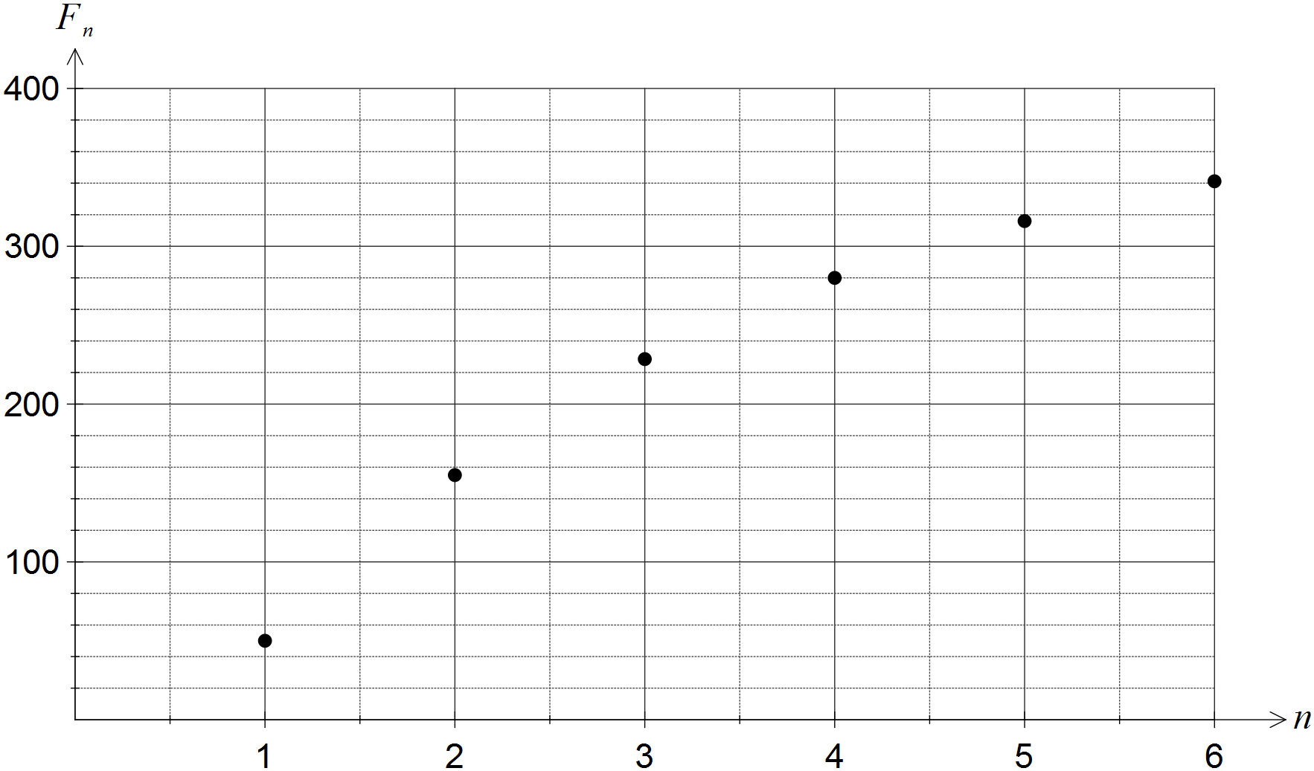
Solution
See graph
Specific behaviours
correct first point (1,50)
at least three other correct points
all points plotted correctly, no attempt to join points

(c) Assuming this model continues, comment on how the number of fish in the tank changes over the next few years. (2 marks)
Solution
Each month, number of fish increase but at a slower rate, until eventually reach a steady state of 400 fish in tank at start of each month.
Specific behaviours
comments on increasing at slower rate
determines long term steady state of 400 fish

Question 16 (9 marks)
An airline has flights between six cities as shown in the graph below. Two of the flights are sightseeing flights that return to the city from which they departed.

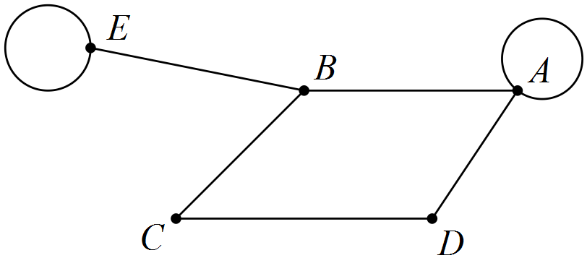

(a) Determine M, the adjacency matrix for this graph. (3 marks)
Solution
Specific behaviours
draws a 5x5 matrix
completes at least three correct rows
completes all rows correctly

(b) Calculate and explain the significance of the elements in this matrix that are zero.
(3 marks)
Solution
A zero indicates that not possible to travel between these cities by taking exactly two flights.
Specific behaviours
shows is a 5x5 matrix
calculates matrix correctly
explains zeros

(c) Determine the number of zero elements in the matrix and explain their significance in terms of specific flight(s). (3 marks)
Solution
There are two zeros, .
There is no way to travel between D and E taking either one or two flights.
Specific behaviours
states number of zeros
states cities involved
states significance

Question 17 (8 marks)
From observations of a random sample of 236 blackbirds, the equation of the least-squares line that models the relationship between the wing span (s, measured in centimetres) and the mass (m, measured in grams) of blackbirds was found to be . The coefficient of determination between the variables was 0.79.

(a) State the percentage of the variation in wing span of blackbirds that can be explained by the variation in their mass and comment on the strength of the association. (2 marks)
Solution
79%
For such a large sample, the high coefficient of determination indicates a strong association between the variables
Specific behaviours
states percentage
states strong association

(b) Calculate the correlation coefficient between s and m, using the fact that the direction of the association is positive. (2 marks)
Solution
Specific behaviours
calculates two possible values
eliminates negative value

(c) Predict the wing span of a blackbird with a mass of 98 grams. (1 mark)
Solution
Specific behaviours
calculates wing span

(d) Explain why it is difficult to comment on the reliability of the prediction in (c). (2 marks)
Solution
There is strong association between variables, which would indicate good reliability. However, as no original data is supplied, there is no way of telling if the prediction involves extrapolation, which is potentially unreliable. Hence difficult to comment.
Specific behaviours
indicates no data to check whether extrapolation is involved
mentions strength of association is good

(e) The mean mass of the birds in the sample was 84.8 grams. Determine the mean wing span of birds in the sample. (1 mark)
Solution
Specific behaviours
calculates mean span

Question 18 (8 marks)
An art gallery records the value of all artworks at the start of each year for insurance purposes. The first valuation of a picture was $4 800, and at the start of the next two years the picture was valued at $5 040 and $5 292 respectively.

(a) Show that the picture values form a geometric sequence. (2 marks)
Solution
Both ratios of terms same, which is consistent with geometric sequence
Specific behaviours
calculates ratio using two pairs of values
states ratios are the same and draws conclusion

(b) Assuming that the value of the picture continues to increase in this way,

(i) calculate the increase in value of the picture during the third year. (2 marks)
Solution
Specific behaviours
states 5% increase per year OR calculates term 4
calculates increase

(ii) calculate the insurance premium for the picture in the tenth year, if the premium is 2.5% of the value of the picture. (2 marks)
Solution
Specific behaviours
calculates value in tenth year
calculates premium

(iii) determine the year in which the insurance premium, still 2.5% of the value of the picture, will first exceed $300. (2 marks)
Solution
The premium for the 20th year.
Specific behaviours
calculates required value
determines correct year

Question 19 (9 marks)
The vertex H on the graph below represents a hotel and vertices A to E represent tourist attractions. The numbers on the edges of the graph below represent the walking times, in minutes, between the various attractions.

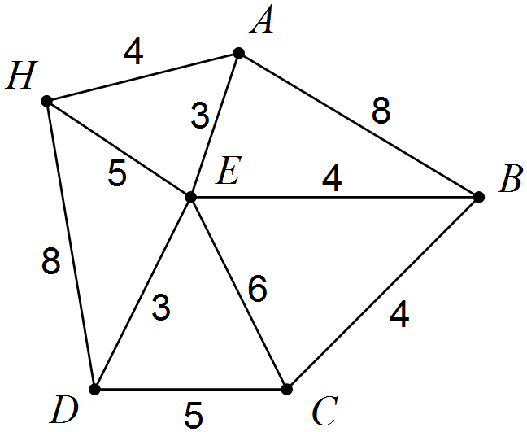

A group of tourists plan to leave the hotel at 10 am and visit all the attractions, spending 15 minutes at each one.

(a) Given that the hotel bus will pick them up from the last attraction they visit,

(i) determine the route they should take that involves the least possible walking time.
(2 marks)
Solution
H - A - E - D - C - B
Specific behaviours
lists vertices that form a Hamilton path
lists shortest Hamilton path

(ii) determine the time the bus should meet them at their last attraction. (2 marks)
Solution
Bus should meet them at 11:34 am.
Specific behaviours
calculates total walking and viewing time
states correct pick up time

(b) One member of the group knows a little about graph theory and suggests that the route that the group plan should be a Hamiltonian cycle.

(i) Explain what is meant by a Hamiltonian cycle. (2 marks)
Solution
A closed walk that starts and ends at the same vertex and visits all vertices once.
Specific behaviours
states walk is closed
states visits all vertices just once

(ii) Determine the Hamiltonian cycle the group of tourists should walk and state the time they will arrive back at their hotel. (3 marks)
Solution
H - A - E - B - C - D - H
Arrive back at 11:43 am.
Specific behaviours
states correct cycle
calculates total walking and viewing time
states correct return time

Additional working space

Question number: _________

Additional working space

Question number: _________

Additional working space

Question number: _________

© 2016 WA Exam Papers. Kennedy Baptist College has a non-exclusive licence to copy and communicate this paper for non-commercial, educational use within the school. No other copying, communication or use is permitted without the express written permission of WA Exam Papers.



Semester One Examination, 2016

Question/Answer Booklet

MATHEMATICS

SOLUTIONS
APPLICATIONS
UNIT 3

Section Two:

Calculator-assumed

Student Number: In figures

In words

Your name

Time allowed for this section
Reading time before commencing work: ten minutes
Working time for section: one hundred minutes

Materials required/recommended for this section
To be provided by the supervisor
This Question/Answer Booklet
Formula Sheet (retained from Section One)

To be provided by the candidate
Standard items: pens (blue/black preferred), pencils (including coloured), sharpener, correction fluid/tape, eraser, ruler, highlighters

Special items: drawing instruments, templates, notes on two unfolded sheets of A4 paper, and up to three calculators approved for use in the WACE examinations

Important note to candidates
No other items may be taken into the examination room. It is your responsibility to ensure that you do not have any unauthorised notes or other items of a non-personal nature in the examination room. If you have any unauthorised material with you, hand it to the supervisor before reading any further.

